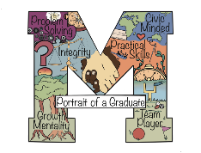
Strategic Plan Objective
Monitoring Report
Objective 3A

Objective 3A: Mancos School District grading will become standards-based, with formative and summative assessments aligned to district priority standards.

Definition of terms:

Standards-based reporting – “reporting” is the process by which grades and scores are shared in parent- and student-facing reports; in a traditional report card, grades and scores are weighted and averaged to arrive at a single grade; in a standards-based report card, individual scores – aligned to a set of standards such as Colorado State Standards, Common Core Standards, or Next Generation Science Standards (NGSS) – remain visible and unaveraged
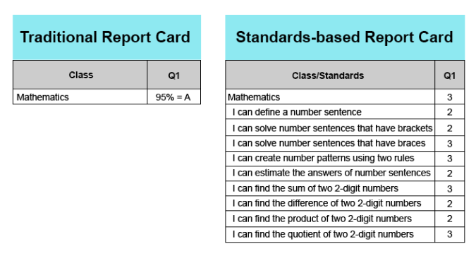
Image from https://www.teacherease.com/standards-based-grading.aspx

Standards-based grading – “grading” includes the practices teachers use to assign grades and scores to individual assignments; when grades and scores are based on content standards, these can be said to be “standards-based”; however, a gradebook can contain scores on items that are also considered to be important, such as Portrait of a Graduate skills, participation, and following directions

Formative assessment – assessments that occur while teaching and learning are still in progress; informs the student, teacher, and parent about progress towards the learning target; these help “form” the learning

Summative assessment – assessments that occur at the end of the learning cycle; these are the “sum” of learning

Priority/power standards – a set of standards that are so foundational to other standards in a content that their teaching becomes a priority

Non-negotiable standards – the term secondary teachers adopted in 2021 as they were developing priority/power standards while considering, “What skills and knowledge would any graduate of Mancos need in order to be successful, no matter what post-secondary path they chose?”

Superintendent’s interpretation: Mancos School District aligns its curriculum and assessment protocols to Colorado Academic Standards. Our “district priority standards” are a set of standards that are so foundational to other standards in a content that their teaching becomes a priority. Students are meeting these standards by demonstrating their achievement in internal and external formative and summative assessments. Our teachers teach a curriculum that is aligned to standards. However, an assigned grade is not always a direct correlation to mastery of standards. I do not see a short-term or mid-range path to make course final grades show mastery of content and skills. One way we are measuring achievement is through graduation, concurrent credits, and career certificates.

Rating: Approaching Standard with strong movement towards At Standard.

Rationale:

Grading across the K-12 campus is standards based, in that teachers teach with the standards at the center of instruction and grade according to mastery of those standards.

Reporting for grades K-3 is standards based, while reporting for grades 4-12 is not standards based at this time. We are constrained by the limits of the reporting system we use (PowerSchool/PowerTeacher).

In the past, the elementary used a standards-based report card that listed out all standards for each grade. See attachment “K 2017-2018,” which is an example of a kindergarten quarter 2 report card from 2017. The elementary principal reports that the length of this report was cumbersome for some parents. As a result, the elementary switched to a “standards supported” report card. See “K 2020-2021,” which is an example of a kindergarten end-of-year report card from 2021. “Standards supported” means that state standards guide instruction, but reporting is limited to the priority standards. Information regarding the extent to which teachers used traditional vs. standards-based grade reporting was provided in March of 2022’s Strategic Plan Report.

The elementary uses the Journeys and Math in Focus curricula as internal assessments to assess growth in language arts and mathematics.
NWEA/MAPs, DIBELS, and STAR tests are forms of external formative assessments. These scores are not used in assigning grades to students; they are not entered into the gradebook and are not a part of any final grade. Instead, the data is shared with students and parents; this happens to a greater extent at the elementary level than at the secondary level. Additionally, teachers use the information gathered from these assessments to plan individual and whole group instruction. See Tables 1-3 for the district’s external formative assessment schedule.

Elementary Testing Schedule
Grade | Tests | Time Administered
K | NWEA Reading  NWEA Math  STAR Reading  STAR Math  DIBELS | Winter, Spring  Winter, Spring  Monthly (when ready)  Monthly (when ready)  Weekly (if on reading plan)
1 | NWEA Reading  NWEA Math  STAR Reading  STAR Math  DIBELS | Fall, *Winter, Spring  Fall, *Winter, Spring  Monthly  Monthly  Weekly (if on reading plan)
2-4 | NWEA Reading  NWEA Math  *NWEA Language  STAR Reading  STAR Math  DIBELS | Fall, Winter, Spring  Fall, Winter, Spring  Fall, Winter, Spring  Monthly  Monthly  Weekly (if on reading plan)
5 | NWEA Reading  NWEA Math  NWEA Language  *NWEA Science  STAR Reading  STAR Math  DIBELS | Fall, Winter, Spring  Fall, Winter, Spring  Fall, Winter, Spring  Fall, Winter, Spring  Monthly  Monthly  Weekly (if on reading plan)
Table 1 – *indicates what is added or different at each level

Middle School Testing Schedule
Grade | Tests | Time Administered
6-8 | NWEA Reading  NWEA Math  NWEA Language  NWEA Science | Fall, Winter, Spring  Fall, Winter, Spring  Fall, Winter, Spring  Fall, Winter, Spring
Table 2
High School Testing Schedule
Grade | Tests | Time Administered
9 | NWEA Reading  NWEA Math  NWEA Language  NWEA Science  PSAT | Fall, Winter, Spring  Fall, Winter, Spring  Fall, Winter, Spring  Fall, Winter, Spring  April
10 | NWEA Reading  NWEA Math  NWEA Language  NWEA Science  ASVAB  PSAT | Fall, Winter, Spring  Fall, Winter, Spring  Fall, Winter, Spring  Fall, Winter, Spring  October  April
Table 3

Summative external assessments are not included in the tables above. These assessments include CMAS, Accuplacer, ACT Workkeys, and SAT.

The high school uses a traditional report card, sent out at the end of each semester. See “HS 2021-2022” which shows a 10th grade report card for 2021-2022.

New secondary teachers in the fall of 2022, in setting up their gradebooks, were encouraged to create two assignment categories, “formative” and “summative.” This way, parents and students could easily determine if an assignment was meant to assess movement towards mastery or to measure mastery itself.

A few years ago, the school subscribed to MasteryConnect, a standards-based reporting system. There were mixed results; some teachers became early adopters of the system and some teachers had difficulty with the multiple steps required for reporting. Teachers reported that having to input scores and grades into two systems (MasteryConnect and PowerTeacher) was overwhelming and time consuming. Our subscription to MasteryConnect was discontinued around 2019 and the curriculum mapping that teachers had done on the site has been permanently lost. However, after having developed the non-negotiable standards, secondary is now creating curriculum maps that include the driving questions, guiding skills and standards, and assessments.

Additional current report cards from elementary are shared in the packet, as is an example of the NWEA/MAPs data that was given to parents. In addition, the board requested the secondary non-negotiable standards that were developed at the secondary level, and these have been included.

The Board has supported administrative efforts to create time and space to support student Capstone Projects for 2023/24 and through schedule restructuring.

Needs and next steps:

- A system for discussing NWEA/MAPs tests and their results with parents has been implemented at the elementary level; this needs to be implemented across the district, especially at the secondary level. Elementary sends these data sheets home after MAPs testing. At the recent Parent-Teacher Conferences in September 2022, NWEA/MAPs data sheets were given to secondary parents, along with an interpretation guide written in parent-friendly language. The remaining secondary MAPs data sheets are in the process of being mailed to parents. A spring workday time will be set aside for this conversation.

- A system for encouraging students, especially secondary students, to “try their best” on NWEA/MAPs tests should be looked at. Because these tests are not “for a grade” and grades are often what secondary students and parents care about, the test becomes less and less important to them as they move up in grade level. However, NWEA/MAPs data are the cleanest, clearest form of student growth we currently have access to. As a district, we can discuss how we can better encourage students to show us what they know on these tests. A spring workday time will be set aside for this conversation.

- Secondary is continuing to work on the curriculum mapping process. This is ongoing throughout the year.

- Teachers and administrators need time to grapple with how we can use our existing structures to best communicate with students and parents about standards mastery. With non-negotiable and power standards in place, this is a logical next step. We can also focus our discussions on best, common practices around standards-based grading systems.

- Note that the objective – “become standards-based” – and the rubric language – “assessments show evidence of…longitudinal growth” – are not aligned. One is asking for evidence of standards-based grading while the other is asking for evidence of student growth. Alignment of the objective with the rubric will be a focus of future work by the Board, including at the Board’s summer retreat.

STATEMENT OF COMPLIANCE: I certify that the information contained in this report is true and I am in compliance with the provisions of this policy.

Signed _______________________________________

Date______09.19.22__________________________________________________________

Revised 10/4/2022 A. Farrar

